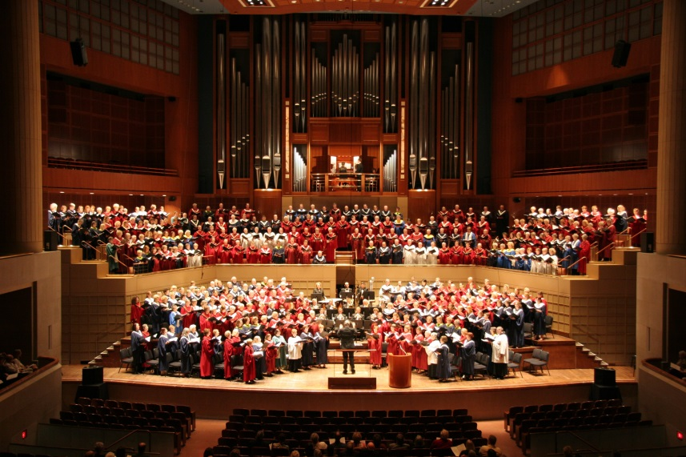

[Festival of Church Music at the Meyerson in Dallas](http://www.churchmusicinstitute.org/festival-of-church-music-at-the-meyerson-in-dallas/)

Coming November 3rd… a choir of over 500 singers, with brass ensemble… filling the Meyerson stage

and choral terrace… leading a congregation of 2000 singing the music of the Church!

Sunday, November 3, 2013  
7:00 pm  
Meyerson Symphony Center  
Dallas, Texas

Paul Leddington Wright, conductor Mary Preston, Organist

Composer Hal Hopson, Honoree

**Our church choir will be singing praise to God with choirs from across North Texas.**

**Please join us for this special festival of song.**

To order tickets locally, contact **__________________________**at **_________________**.

More information and tickets ($20, $15 and $10) available at [www.churchmusicinstitute.org](http://www.churchmusicinstitute.org) or by calling CMI at 214-751-7669

Tickets ordered by October 23 will be mailed; later orders will be available

at the Will Call Table the night of the festival.

