120 Bible Stories (ages 6-10)
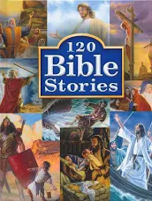

A Child’s Garden of Bible Stories (ages 6-8) 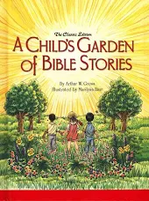

Little Visits for Families (ages 4-10) 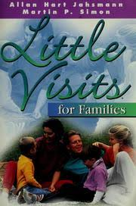

Little Visits for Toddlers (ages 1-2) 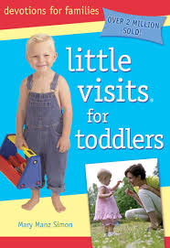
Little Visits with God (ages 4-10)
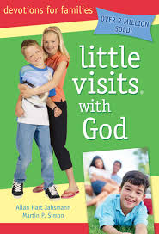

Little Visits with Jesus (ages 4-10) 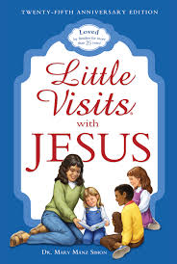
My Church Words Book (ages 1-4) 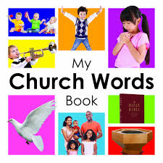

My First Catechism (ages 6-10)
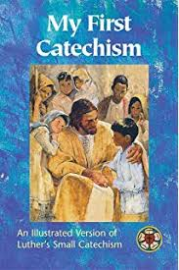

My First Hymnal (ages 4-10)
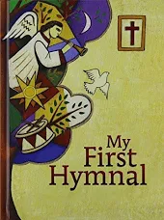

One Hundred Bible Stories (ages 8-12)

Right from the Start (adult)
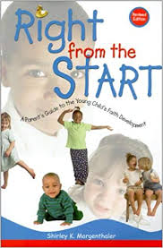

The Story Bible (ages 3-10)
